Stock Control
Checking stock levels, movements and what is on order
Fuse Manufacturing — user guide 05

Before you start
Stock Control is for looking, not for doing. Nothing on these screens changes stock. You cannot break anything here, so explore freely.
Use it to answer four kinds of question: how much do we have, where is it, what has moved, and what is still coming from suppliers.
It is also the quickest way to check your own work. After recording a transfer or a production run, come here and confirm the figures moved the way you expected. Getting into that habit will catch a mistake while it is still easy to undo.
- On Fuse Home, click Stock Control.
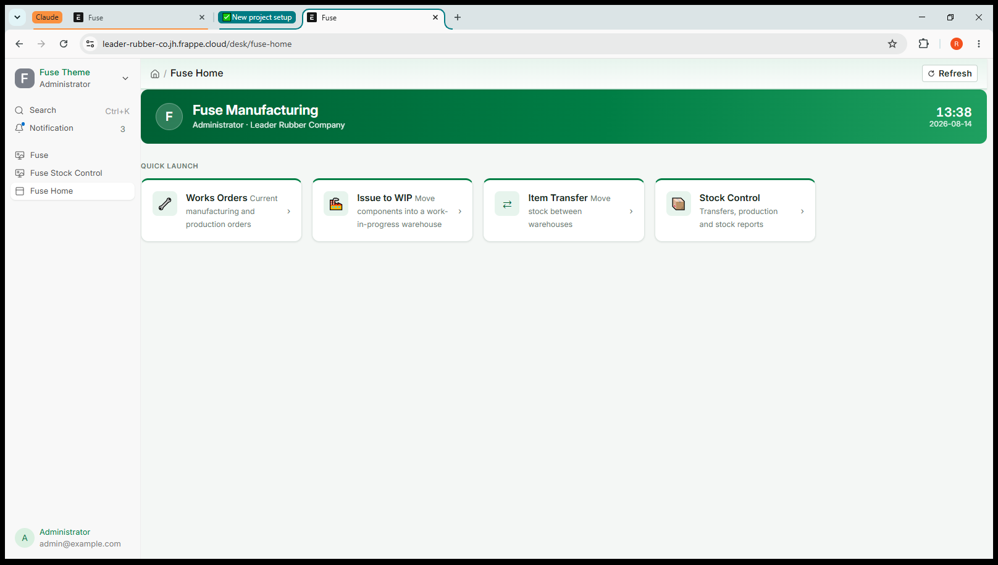
Screenshot 1 — Fuse Home
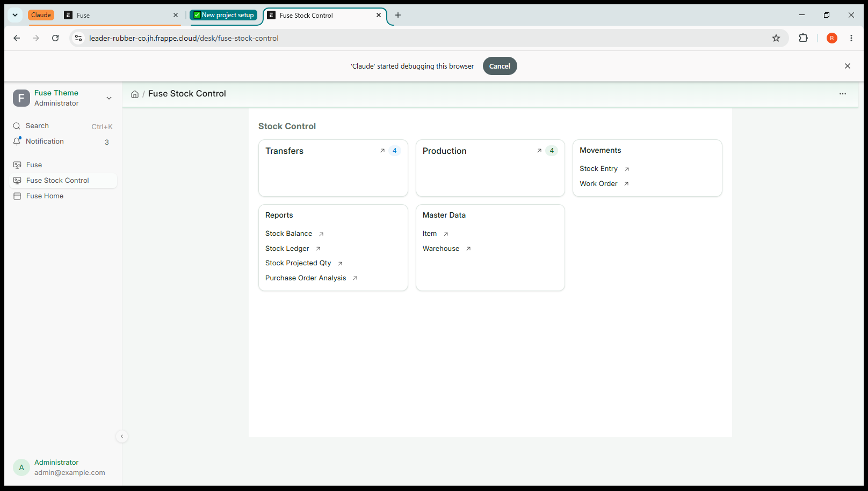
Screenshot 2 — The Stock Control screen

The shortcuts along the top
Each opens a filtered list, and the number beside it is how many there are.
- Transfers — every warehouse transfer and issue to WIP that has been recorded.
- Production — every manufacturing entry.
Use these to find a document you recorded earlier, whether to check it or to cancel it.

Movements
- Stock Entry — every stock movement of every kind, in one list.
- Work Order — all works orders, including those already finished.

The four reports

Stock Balance
What you hold right now, by item and by warehouse, with its value.
This is the report to open when the question is simply “how much have we got, and where”. It is also the one to use when checking your own work: record a movement, open this, and confirm both warehouses moved by the amount you expected.

Stock Ledger
Every movement of an item in date order, showing what each one did to the quantity and which document was behind it.
This is the report that answers “where did that stock go”. When a figure looks wrong, open the ledger for that item and read down until you find the movement that does not belong.

Stock Projected Qty
The planning report. For each item and warehouse it shows what you actually hold, what is on order from suppliers, and the projected total once those orders arrive.
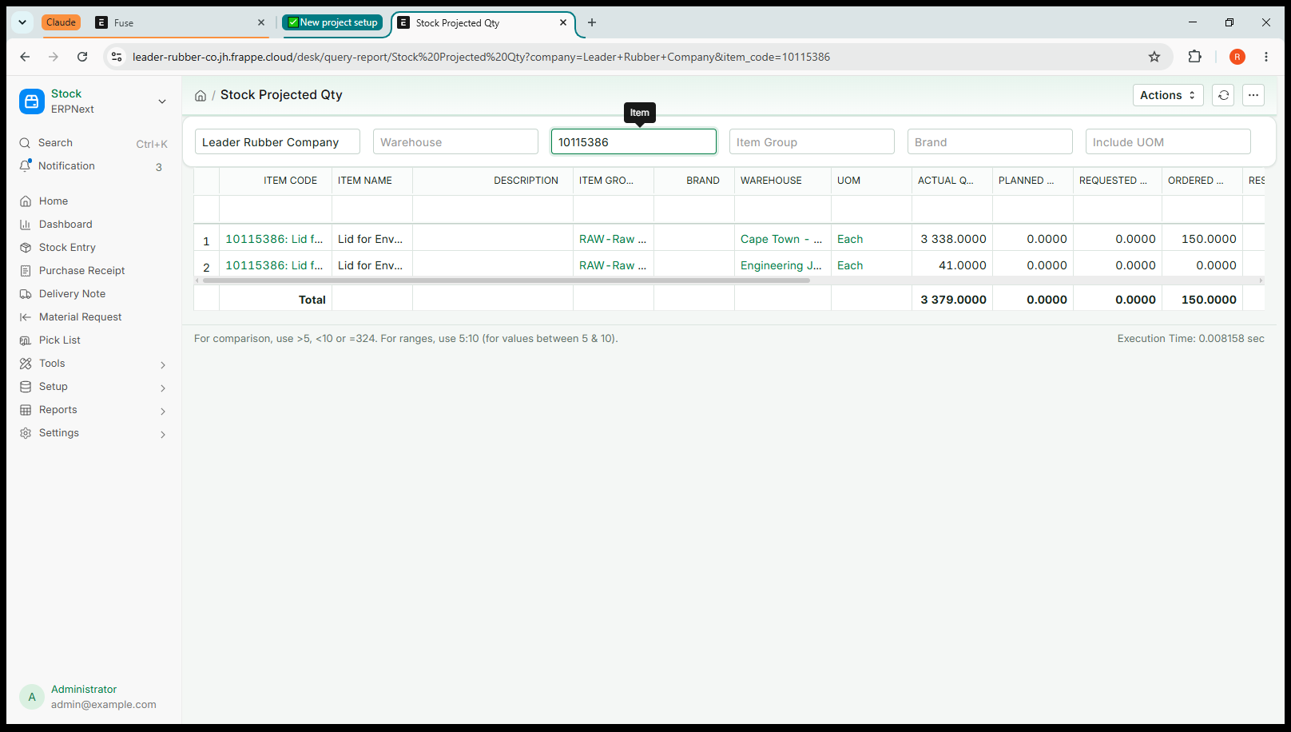
Screenshot 3 — Stock Projected Qty — 3,338 in stock and 150 on order
In that example the warehouse holds 3,338, a further 150 are on order, and the projected figure is 3,488.
If you are deciding whether to order more, this is the number to look at. Judging by the quantity on hand alone is how a business orders material it has already ordered.

Purchase Order Analysis
The same information line by line: which order, which supplier, what was ordered, how much has been received, how much is still to come, and when it is due.
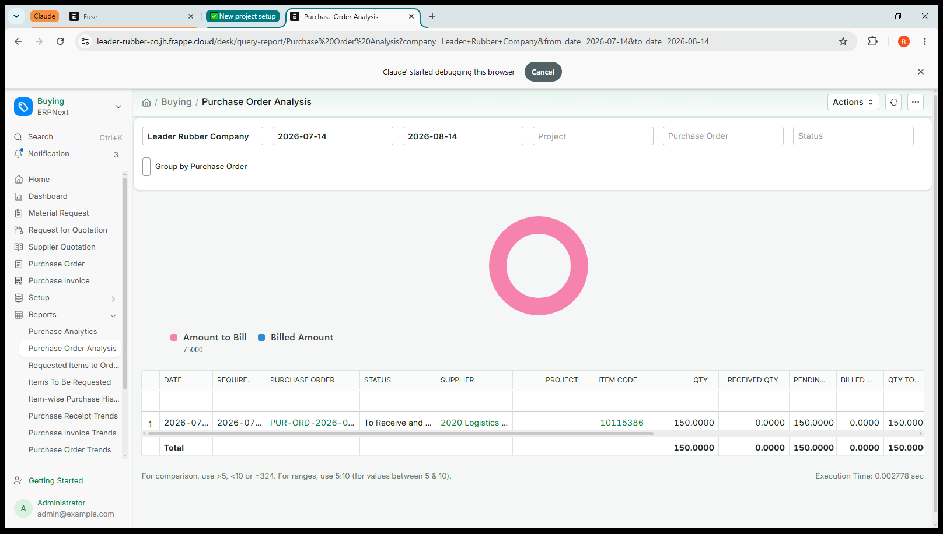
Screenshot 4 — Purchase Order Analysis — one order still to be delivered
The date filters at the top default to roughly the last month. Widen them if you are looking for an older order and cannot find it.

Where purchase orders come from
Purchase orders are raised in Sage Intacct, not in Fuse. Fuse copies the open ones across so that stock still to arrive appears in your planning figures, with the quantity outstanding and the due date.
As Intacct receives against an order, the outstanding quantity here falls to match. Once nothing is left outstanding, the order drops out of the on-order figure by itself. Nobody has to close anything here.
This copy happens automatically through the day, so an order raised in Intacct this morning will appear here shortly afterwards rather than instantly.

Goods are received in Intacct
Fuse shows you what is on order so you can plan, but the receipt itself is recorded in Intacct. If you try to receive goods in Fuse it will refuse and tell you why. That is deliberate: receiving in both places would count the same delivery twice.

Master Data
- Item — the item list, with codes, descriptions and units.
- Warehouse — the warehouse list.
Both come from Intacct and are read-only here. Look anything up you like, but changes must be made in Intacct or they will be overwritten at the next sync.
If an item or warehouse you need is missing, that is a job for your administrator — it means something has not come across from Intacct.

Checking your own work
A short routine worth learning, and worth teaching anyone you hand over to:
- Record the movement and submit it.
- Open Stock Control, then Stock Balance.
- Filter to the item and check both warehouses moved by the amount you expected.
- If something looks wrong, open Stock Ledger for that item and read the movements in date order until you find the one that does not belong.
- If it was your entry, open it and cancel it. If it was not, tell your supervisor rather than trying to correct it with another movement.

Jobs that belong in Intacct
Fuse will stop you doing these, with a message explaining why. Nothing is saved and nothing is broken — the job simply belongs in the other system.

If you try to | What happens
Receive goods from a supplier | Refused. Goods receipting is done in Intacct. Fuse shows what is on order so you can plan, but the receipt is recorded there.
Adjust stock up or down | Refused. On-hand corrections are made through a Cycle Count in Intacct.
Change an item, warehouse or supplier | Read-only here. These come from Intacct, and a change made in Fuse would be overwritten at the next sync.

Quick reference

Question | Where to look
How much do we have, and where? | Stock Balance
Where did that stock go? | Stock Ledger
What is coming, and when? | Stock Projected Qty, or Purchase Order Analysis
Should we order more? | Stock Projected Qty — use the projected figure, not on hand
Which transfers were done today? | The Transfers shortcut
What was produced? | The Production shortcut
What does this item cost? | Stock Balance shows the value it is held at

Where this goes
Fuse and Sage Intacct hold the same stock. Anything you submit here is sent to Intacct immediately, and Fuse only records it once Intacct has accepted it. If Intacct refuses, nothing is saved in either system and you will see the reason on screen.

